# Assign#5

## Exercise 5.1 – Configuring Windows 11

|  |  |
| --- | --- |
| Question 1 | Which is the largest application and what is the size?  Microsoft OneDrive |

Step 12: Take a FULL SCREEN SHOT showing the Start page.

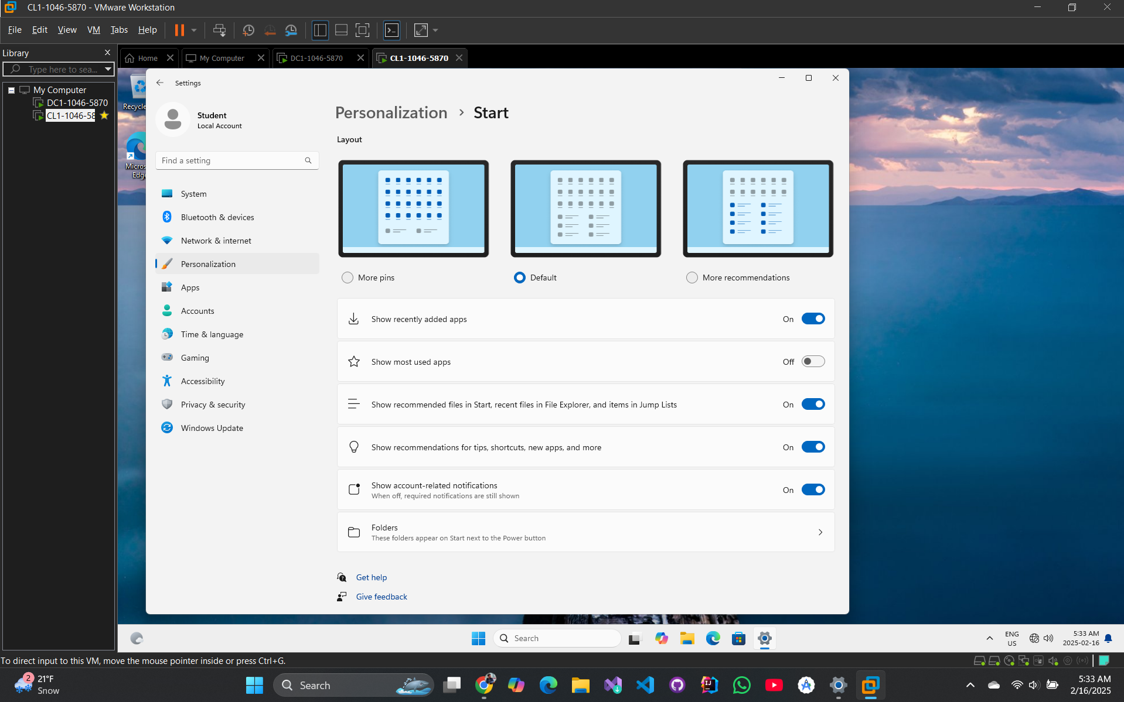

|  |  |
| --- | --- |
| Question 2 | How much RAM does your system have?  4 GB |

## Exercise 5.2 – Configuring Power Settings

|  |  |
| --- | --- |
| Question 3 | Which power plan is being used by the system?  Balanced |

Step 9: Take a FULL SCREEN SHOT of the Power Options page.

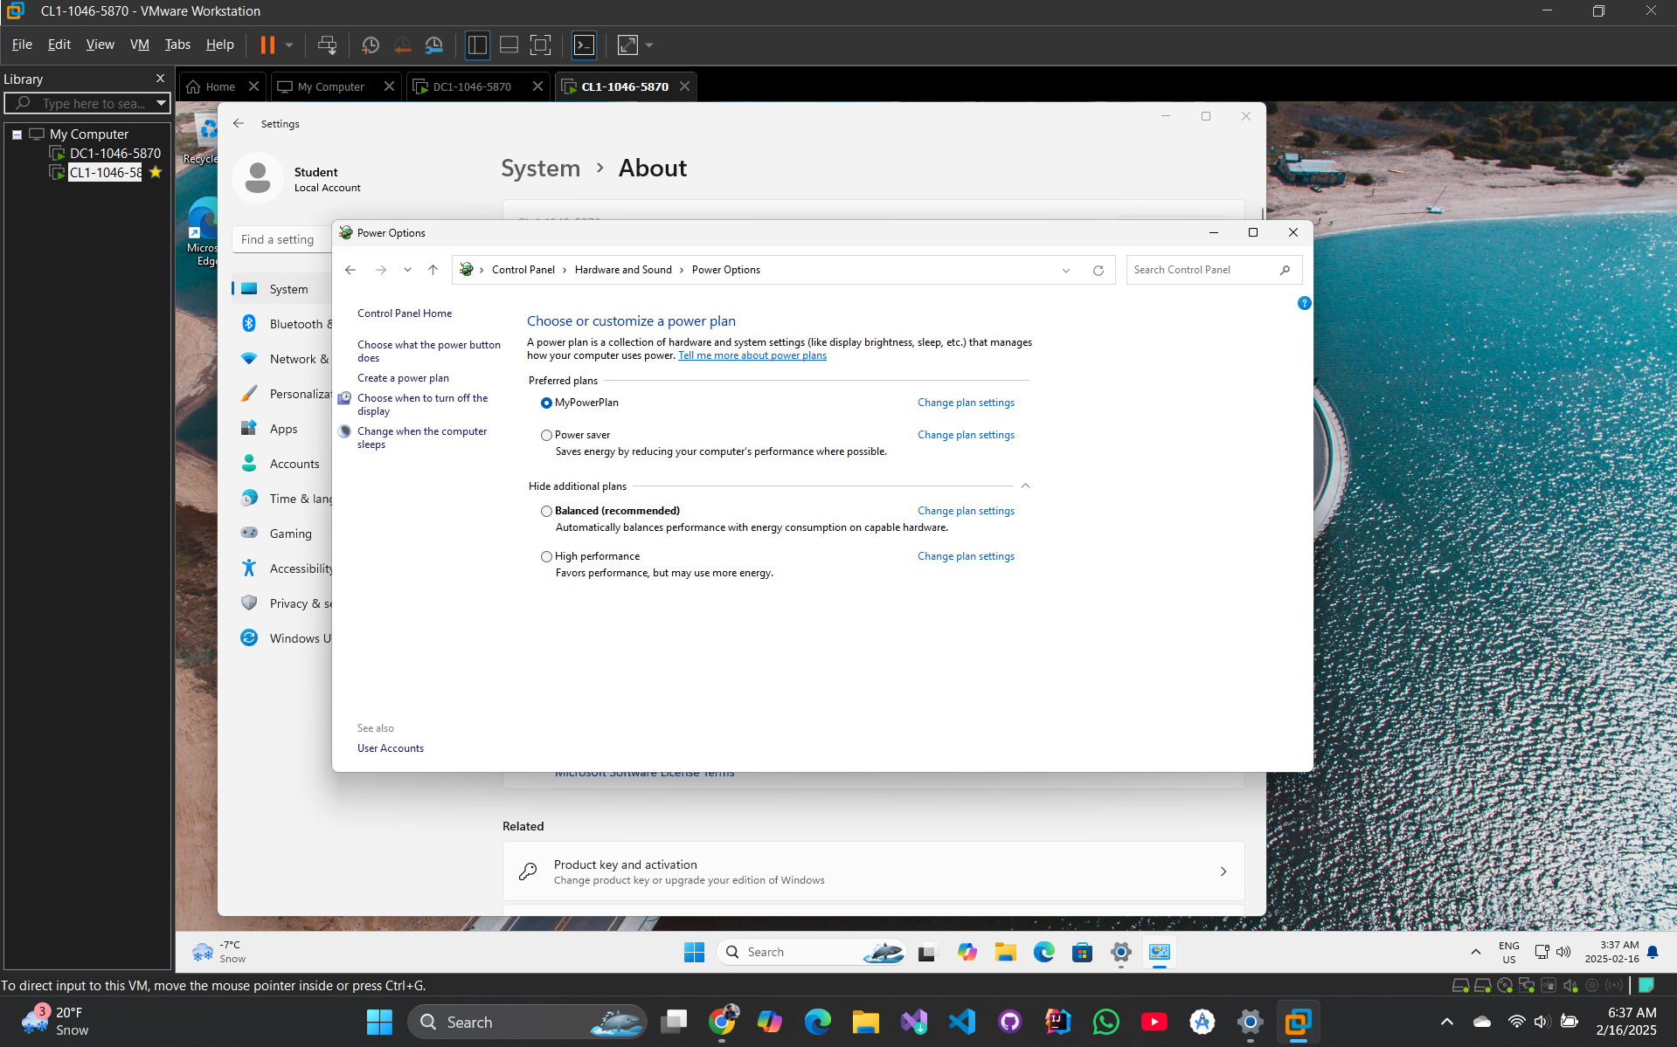

|  |  |
| --- | --- |
| Question 4 | At what point is the hard disk turned off when it's not being used?  20 minutes |

## Exercise 5.3 – Configuring Internet Explorer

Step 21: Take a FULL SCREEN SHOT of the Local Area Network (LAN) Settings dialog box.

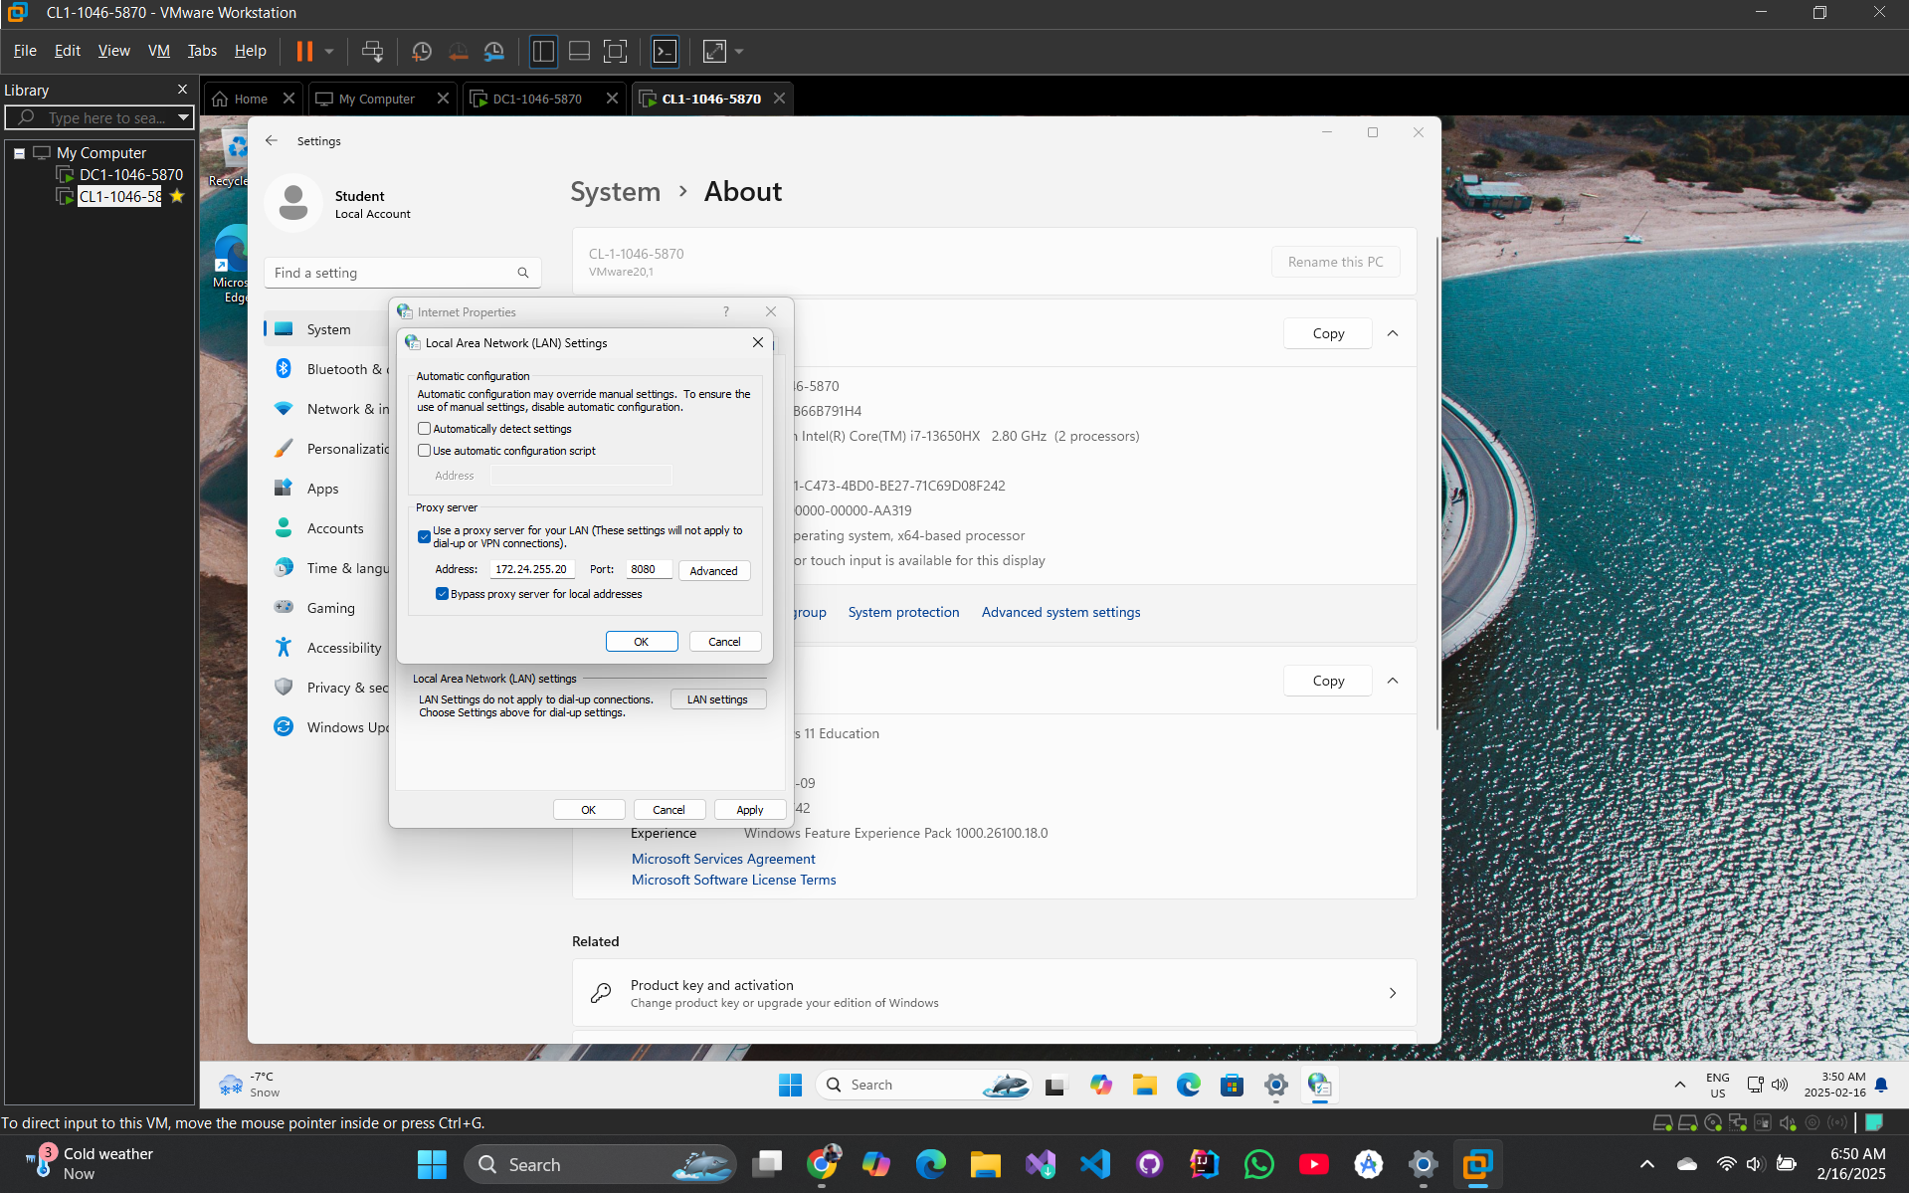

Step 32: Take a FULL SCREEN SHOT of the Internet Explorer compatibility page.

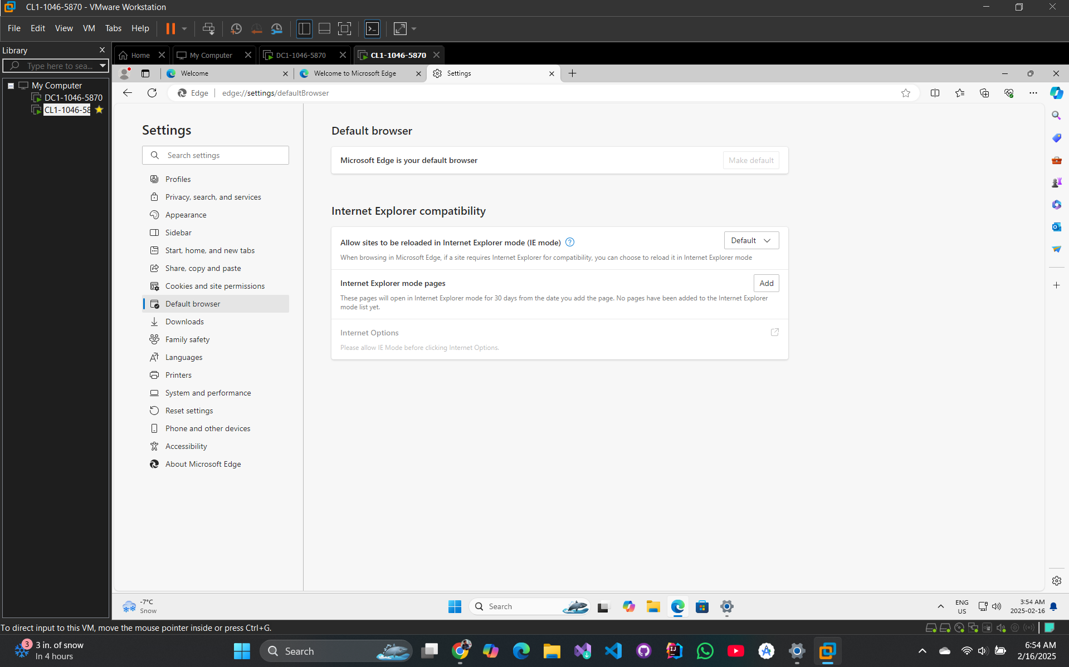

## Exercise 5.4 – Configuring Microsoft Edge

Step 21: Take a FULL SCREEN SHOT of the Can't reach this page window.

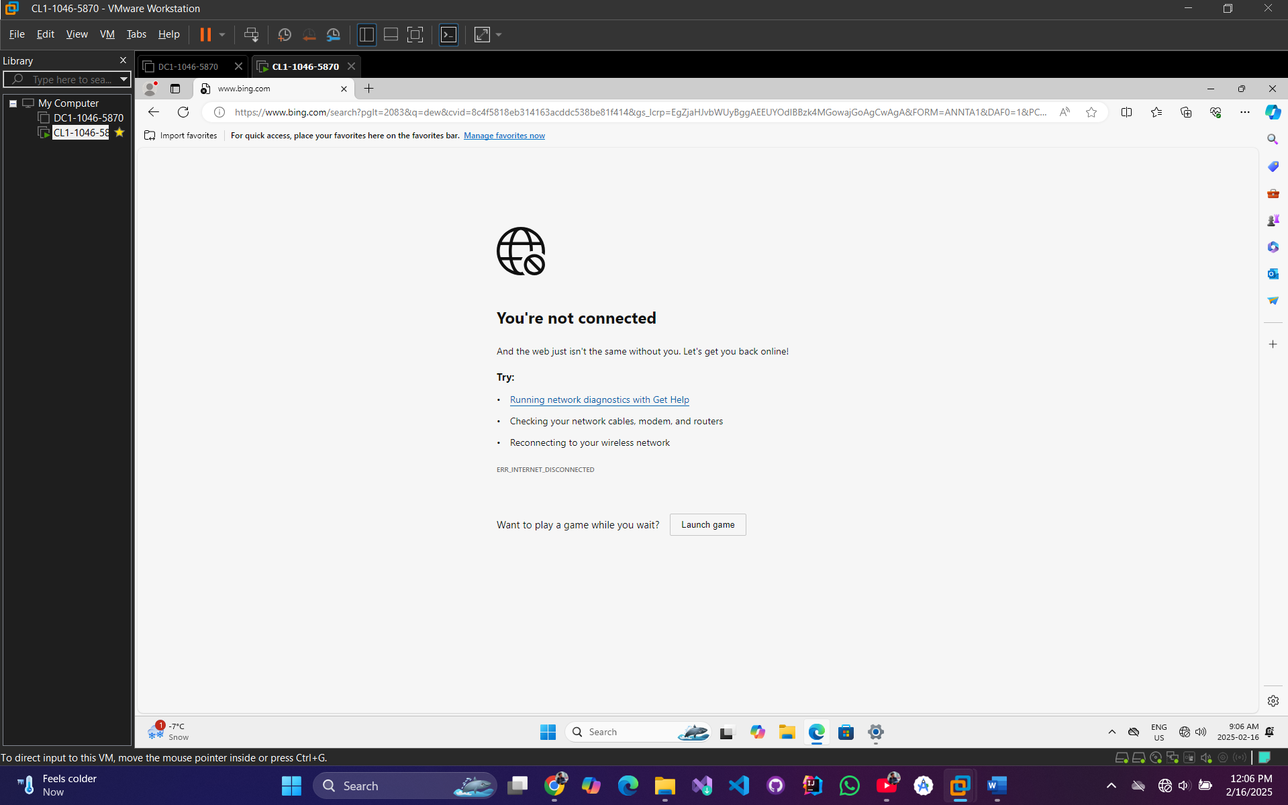

## Exercise 5.5 – Configuring User Account Control (UAC)

Step 11: Take a FULL SCREEN SHOT showing the Group Policy Manager Editor window.

